Tutorial for Talking Avatar

1. Open the Scene in which you would like to insert the Talking Avatar. If you do not already have a Unity Scene you would like to add the Avatar in simply create a new one
2. Import the Avatar Package by going to Assets→ Import Package→ Custom Package and Select the Avatar Unity Package
3. Next you will need to create an Animator Controller for the Avatar. Go to Assets→ Create→ Animator Controller. Name the Controller anything you would like
4. Next open up the Animator Window by going to Window→ Animator. You should see a screen that looks like the picture below

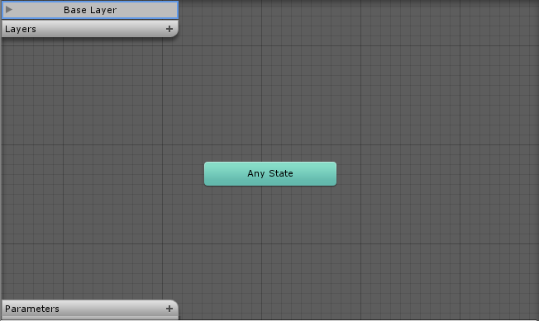

1. In the Assets folder you should find two animations: Head movement and Mouth moving. Drag the Head movement into the Animator and then drag the Mouth moving into the Animator twice. The Animator should now look similar to the picture below

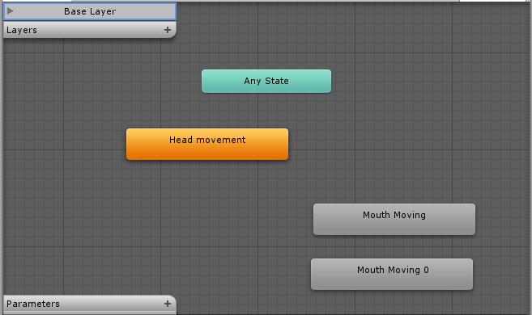

1. Now that both animations are in the controller we will need to make transitions between the two. Right Click the Animations and select make transition. An arrow will then appear which you can attach to other animations. Make Transition paths to match the picture below. You can move the animation state by simply clicking and dragging. If you need to delete a transition simple click it and press delete

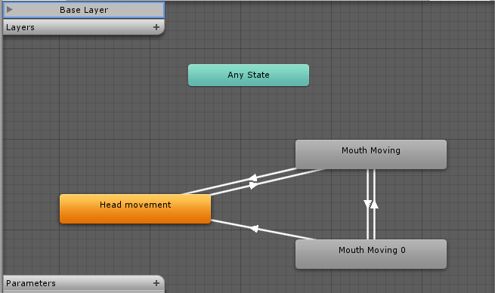

1. Now that we have set up the transitions we need to add a parameter to be a trigger. Click the + on the Parameters Tab and select Bool. Name the new parameter Audio. **Make sure the box beside Audio is unchecked**
2. Now we need to add the parameter to the transitions. Click the transition going from the Head movement to the Mouth moving. You should see a window like the picture below

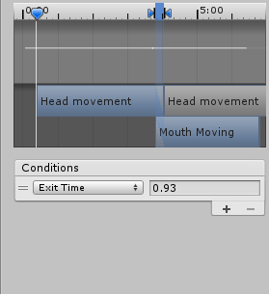

1. Click the Drop down box where it says Exit Time and select the Audio Parameter. Make sure the box beside the parameter is set as true.
2. Now repeat step 9 for both the transitions from Mouth moving to Head Movement except this time have the box beside the parameter set as false. Nothing needs to be done with the two transitions between the two Mouth moving
3. We are now complete with the Animator Controller. Open the Scene window up again and drag carl (located in the Assets Folder) into the scene. The camera will need to be adjusted to be facing carl so that we can see the animation
4. Select carl in the Hierarchy Menu and you should see a window similar to the one below. Click the circle beside the Controller box and Select the Animator that we just created

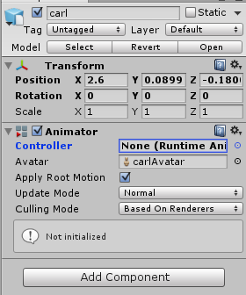

1. Now Select Add Component and go to Audio→ Audio Source. You should see a window similar to the one below

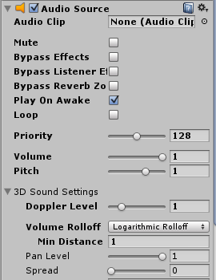

1. Click on the circle beside the Audio Clip box and add either your own audio recording or Voice_002 located in the Assets folder. If you are using your own audio recording it needs to be in mp3 format. If you need to convert it you can do so at <http://www.zamzar.com/convert/m4a-to-mp3/>. **Make sure to uncheck the Play on Awake box**
2. Now click Add Component again and go to Scripts→ Talking Script. A window like the one below should appear



1. Click on the circle beside the Anim box and select carl. You can now play the scene. The avatar will not begin talking until you press the “T” button on the keyboard. Only press it once otherwise it will not behave correctly. The avatar will continue talking until the audio is finished. The Talking Script can be edited to have any button trigger the talking, including something being clicked in the scene.